• **Use React framework** to build your application with at least

* 3 components
* 4 props
* 2 state properties
* 2 setState
* 2 routes

API : Map, sunlight, tides

Google maps, Sunlight free, tides max 50 calls/day (apikey)

<https://developers.google.com/maps/> (refer geocoding, want coordinates aka lat long)

<https://developers.google.com/maps/documentation/geocoding/overview>

<https://sunrise-sunset.org/api>

<https://docs.stormglass.io/#/>

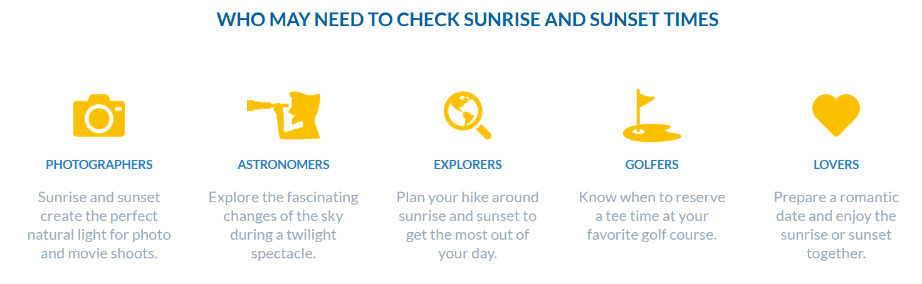• **Use 3rd party API and/or Firestore**

* API call with Axios and display the data for the user. You may use any API of your choosing or [Find an available API here](https://github.com/public-apis/public-apis)
* You may also opt to use Firebase/Firestore if you need to store data.